PHE NW COVID-19 Template Resource Pack for Workplaces

Version 2.2

(Cheshire and Merseyside Version for local adaptation by partners)

February 2021

About Public Health England

Public Health England exists to protect and improve the nation’s health and wellbeing and reduce health inequalities. We do this through world-leading science, knowledge   
and intelligence, advocacy, partnerships and the delivery of specialist public health services. We are an executive agency of the Department of Health and Social Care, and a distinct delivery organisation with operational autonomy. We provide government, local government, the NHS, Parliament, industry and the public with evidence-based professional, scientific and delivery expertise and support.

|  |  |  |  |
| --- | --- | --- | --- |
| **Document Change History** | | | |
| Version | Status | Author | Details of Change/Superseded document | |
| **v0.1** | **DRAFT** | **Emma Savage/Katie Smith/Merav Kliner** | First draft of document | |
| **V0.4** | **DRAFT** | **Emma Savage/Katie Smith/Merav Kliner** | Draft version of document. | |
| **v1.0** | **FINAL** | **Emma Savage/Katie Smith/Merav Kliner** | Final version of document for circulation | |
| **v2.0** | **FINAL** | **Emma Savage/Katie Smith/Merav Kliner** | Updated version of document for circulation to hubs and handover to NW Business Cell. Changes are highlighted in yellow and as follows:   * Updated isolation period for contacts to 10 days – pg 12 * Changed references to “CTAS ID” to “Account ID” – pgs 16. 22. 27 * Updated embedded Case Management checklist in Appendix 1 * Added guidance for household contacts in the event of a negative test result in Figure 3 flow chart * Updated template letters in Appendix 3 with 10 day isolation period guidance | |
| **v2.1** | **Final** | **Rita Huyton** | Cheshire and Merseyside Hub changes  Skin to skin contact removed from definition of a contact  15 min contact definition updated to include “either as a one-off contact, or added up together over one day” | |
| **V2.2** | **FINAL** | **Rob Begg/Chris McBrien** | Updated to include Knowsley specific tailored advice, documentation and support available. Clinical advice remains consistent. Changes include:   * Local contact details for businesses * Asymptomatic testing – guidance to include twice weekly testing for all staff not working from home. * Localised contact tracing line list, used locally by officers * Confirmatory PCR testing requirements | |
|  |  |  |  | |
|  |  |  |  | |
|  |  |  |  | |
|  |  |  |  | |

### Contents

Contents 4

Section 1: Local Area Key Contacts 6

Section 2: COVID-19 Key Messages 7

Section 3: Management of a suspected case 10

Section 4: Management of a single confirmed case 15

Section 5: Management of multiple confirmed cases and possible outbreaks 18

Section 6: Frequently Asked Questions 20

Cases and contacts 20

Testing 24

High risk groups 24

Staff 25

NHS Test and Trace App 27

Financial support 27

Cleaning 27

Section 7: National Guidance Documents 30

Social distancing for different groups 30

Guidance for contacts 30

Specific guidance for workplace settings 30

Testing 31

Infection prevention and control 31

Coronavirus Resource Centre 31

Appendix 1 – Case Management Checklist 32

Appendix 2 – Absence Recording Templates 32

Appendix 3 – Template Workplace Letters 32

Please note that, as COVID-19 is a rapidly evolving situation, guidance may change with little notice.

Therefore we advise that, in addition to familiarising yourself with the content of this document, you refer to the relevant national guidance

(links provided in Section 7)

----------------------------------------

### Section 1: Local Area Key Contacts

|  |  |  |
| --- | --- | --- |
| Knowsley Single Point of Contact (SPOC) Details | | |
| For general queries and advice on managing a potential outbreak please contact:  [COVID19.SPOC@knowsley.gov.uk](mailto:COVID19.SPOC@knowsley.gov.uk)  Or  0151 443 4712  For out side of these hours, and during bank holidays, please contact Public Health England North West (details below) | | Opening Hours:  Mon-Fri: 9:00 – 5:00  Sat-Sun 10:00 – 4:00 |
| Contact tracing hub contact details | | |
| Tel: 0151 666 3400 or [cmcthub@phe.gov.uk](mailto:cmcthub@phe.gov.uk) | |  |
| Public Health England North West: Health Protection Team Contact Details | | |
|  | | |
| The following can be used outside of SPOC opening hours:  Please call 0344 225 0562 (Option 9) |  | |

### **Section 2: COVID-19 Key Messages**

What are the symptoms?

The main symptoms of COVID-19 are:

new continuous cough and/or

fever (temperature of 37.8°C or higher) and/or

Loss of or change in, normal sense of taste or smell (anosmia)

What is the mode of transmission?

COVID-19 is passed from person to person mainly by large respiratory droplets and direct contact (close unprotected contact, usually less than one metre). These droplets can be directly inhaled by a person, or can land on surfaces which a person may touch which can lead to infection if they then touch their nose, mouth or eyes.

What is the incubation period?

The incubation period (i.e. time between exposure to the virus and developing symptoms) is between 1 and 14 days (usually 4-6 days).

What is the infectious period?

The infectious period is the time when someone with the virus can pass it on to somebody else. A person is thought to be infectious 48 hours before symptoms appear, and up to ten days after they start displaying symptoms (national guidance [here](https://www.gov.uk/guidance/nhs-test-and-trace-how-it-works#part-2-people-who-have-had-close-contact-with-someone-who-has-coronavirus)). If a person tests positive but has not had symptoms the infectious period is 48 hours before the date of the test, and up to ten days after the date of the test.

What is a confirmed case?

A confirmed case is any individual who has received a positive test result for COVID-19 (if the person has only received a rapid test, sometimes known as a Lateral Flow Test, result please see the “Testing” in the FAQ section for more information).

What is a close contact?

A ‘close contact’ is a person who has been close to someone who has tested positive for COVID-19 at any time during their infectious period.

**Close contact is considered to be**:

* a person who spends significant time in the same household as a person who has tested positive for COVID-19
* a person who has had face-to-face contact (within one metre), with a person who has tested positive for COVID-19, including:
  + being coughed on
  + having a face-to-face conversation within one metre
* a person who has had contact with a person who has tested positive for COVID-19 within one metre for one minute or longer without face-to-face contact
* a person who has been within 2 metres of someone for more than 15 minutes (either as a one-off contact, or added up together over one day/shift)
* a person who has travelled in a small vehicle with someone who has tested positive for COVID-19 or in a large vehicle or plane near someone who has tested positive for COVID-19

Where an interaction between 2 people has taken place through a Perspex (or equivalent) screen, this would not be considered sufficient contact, provided that there has been no other contact such as any of those indicated above.

The wearing of face coverings or other Personal Protective Equipment (PPE) in a workplace will not prevent a staff member being identified as a close contact if social distancing has not been maintained. However, the wearing of face coverings will reduce the risk of transmission and a staff member developing COVID19.

See [guidance on contacts](https://www.gov.uk/government/publications/guidance-for-contacts-of-people-with-possible-or-confirmed-coronavirus-covid-19-infection-who-do-not-live-with-the-person/guidance-for-contacts-of-people-with-possible-or-confirmed-coronavirus-covid-19-infection-who-do-not-live-with-the-person) for more information.

How long does self-isolation last?

* If a person has had a positive lab test result i.e. a confirmed case of COVID19 they must not leave home for **10** days from the onset of symptoms (or the date of test if they have no symptoms).
* If a person has been identified as a close contact of a confirmed case they must not leave home for **10** days from the date they last had contact with the case. (If they live with the case they have had close contact with they must not leave home for **10** days from the onset of symptoms in the case, or the case’s test date if the case is asymptomatic)

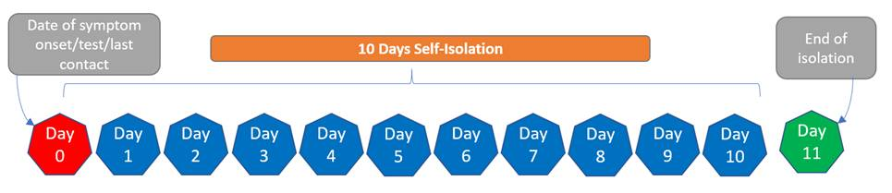

What does self-isolation mean?

Self-isolation means the person should:

* + Not go to work or public places
  + Not use public transport or taxis
  + Not go out to shop – they should order it online or ask a friend to bring it to their home
  + Not have visitors in their home except for people providing essential care
  + Not go out to exercise – exercise at home or in their garden, if they have one
  + Inform their GP practice, hospital or other healthcare setting that they are self-isolating if they must attend in person

What are the protective measures that businesses need to put in place?

There are a range measures you should take to keep your business COVID-secure. The specific details of these measures may vary depending of the type of workplace it is. Please see the [guidance on how to make your workplace COVID-secure](https://www.gov.uk/guidance/working-safely-during-coronavirus-covid-19) which provides different information for a range of workplace settings.

### **Section 3: Management of a suspected case**

What to do if a staff member is unable to attend work because they (or a member of their household) have one or more of the following COVID-19 symptoms:

new continuous cough and/or

fever (temperature of 37.8°C or higher)

Loss of or change in, normal sense of taste or smell (anosmia)

**Anyone who develops symptoms of COVID-19, or whose household member develops symptoms, should immediately self-isolate. They should not attend work.**

* The member of staff should notify the workplace of their absence.
* The household should be advised to follow the [Stay at home guidance](https://www.gov.uk/government/publications/covid-19-stay-at-home-guidance/stay-at-home-guidance-for-households-with-possible-coronavirus-covid-19-infection).The person with symptoms should isolate for 10 days starting from the first day of their symptoms and the rest of their household for 10 days.
* Anyone in the household with symptoms should get tested via [NHS UK](https://www.nhs.uk/conditions/coronavirus-covid-19/testing-for-coronavirus/) or by contacting NHS 119 via telephone if they do not have internet access.
* **You do not need to notify the local authority or PHE Health Protection Team where employees report symptoms.**
* If the test result of the person with symptoms is negative the staff member and their household members can end self-isolation and return to work provided they feel well.
* If the test result is positive, please see Section 4 for the management of cases.
* The workplace should record and keep a minimum dataset on staff absences in case this information is required for outbreak management purposes (see Appendix 2 for suggested template)
* Carry out usual environmental cleaning as per [guidance for cleaning in non-health care settings](https://www.gov.uk/government/publications/covid-19-decontamination-in-non-healthcare-settings/covid-19-decontamination-in-non-healthcare-settings)

**If there are concerns there may be an outbreak in the workplace, for example, there is an overall increase in sickness absence reporting where COVID-19 is suspected (but where no tests have been done or results are not available) then you should follow the advice in** **Section 5****.**

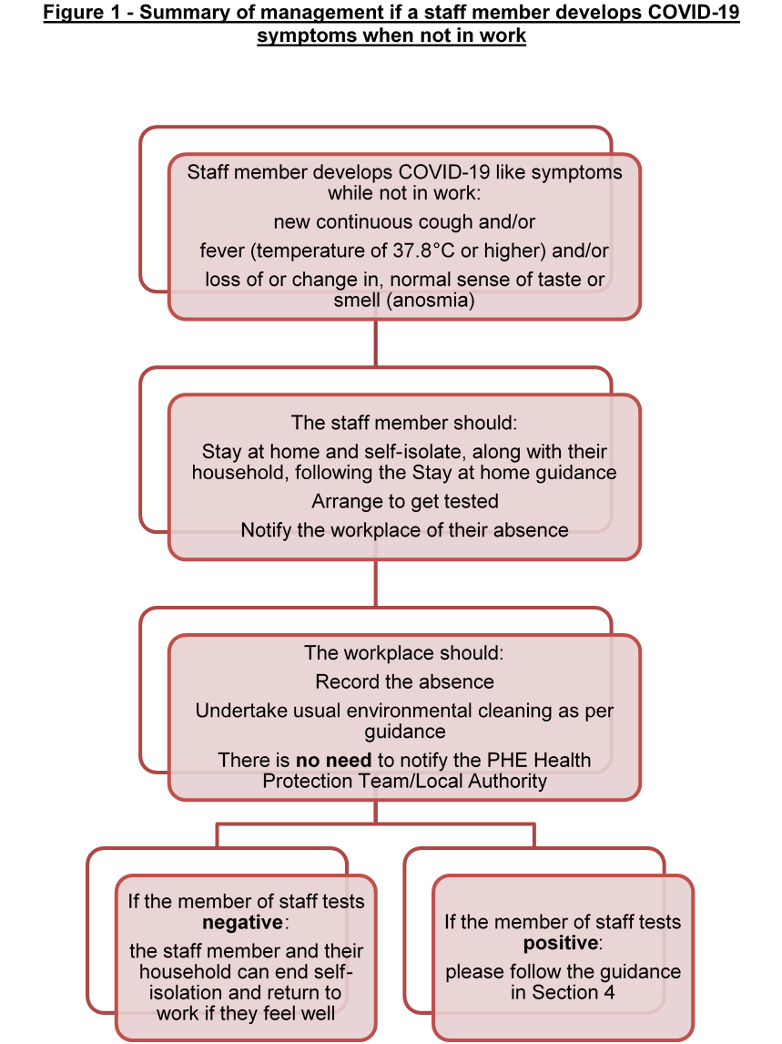

What to do if someone falls ill while at work

**If anyone becomes unwell with a new continuous cough, a high temperature or a loss of or change in their normal sense of taste or smell they must go home as soon as possible and avoid contact with anyone else in the workplace.**

* If they cannot go home by themselves they should isolate away from others, if possible, in a room where they can be isolated behind a closed door until they can be picked up by a member of their household.
* Where possible avoid the use of public transport

* If the staff member requires support from another member of staff and a 2 metre distance cannot be maintained, then the following PPE should be worn by the supporting staff member:
  + Disposable gloves
  + Disposable plastic apron
  + Fluid-resistant surgical face mask
  + Eye protection (goggles, visor) should be worn ONLY if a risk assessment determines that there is a risk of fluids entering the eye from, for example, coughing, spitting or vomiting

The wearing of PPE will reduce the risk of the supporting staff member catching COVID19 but if the ill staff member tests positive then the supporting staff member will be a close contact and need to self-isolate for 10 days. The supporting staff member does not need to self-isolate until the result of the test is known.

* Carry out environmental cleaning as per [guidance for cleaning in non-health care settings](https://www.gov.uk/government/publications/covid-19-decontamination-in-non-healthcare-settings/covid-19-decontamination-in-non-healthcare-settings)
* The household of the unwell staff member should be advised to follow the [Stay at home guidance](https://www.gov.uk/government/publications/covid-19-stay-at-home-guidance/stay-at-home-guidance-for-households-with-possible-coronavirus-covid-19-infection).The person with symptoms should isolate for 10 days starting from the first day of their symptoms and the rest of their household for 10 days.
* Anyone in the household with symptoms should get tested via [NHS UK](https://www.nhs.uk/conditions/coronavirus-covid-19/testing-for-coronavirus/) or by contacting NHS 119 via telephone if they do not have internet access.
* **You do not need to notify the local authority or PHE Health Protection Team.**
* If the test result is negative the staff member and their household members can end self-isolation and return to work provided they feel well.
* If the test result is positive, please see Section 4 for the management of a confirmed case
* The workplace should record and keep a minimum dataset on staff absences in case this information is required for outbreak management purposes (see Appendix 2 for suggested template)

**If there are concerns there may be an outbreak in the workplace, for example, there is an overall increase in sickness absence reporting where COVID-19 is suspected (but where no tests have been done or results are not available) then you should follow the advice in** **Section 5****.**

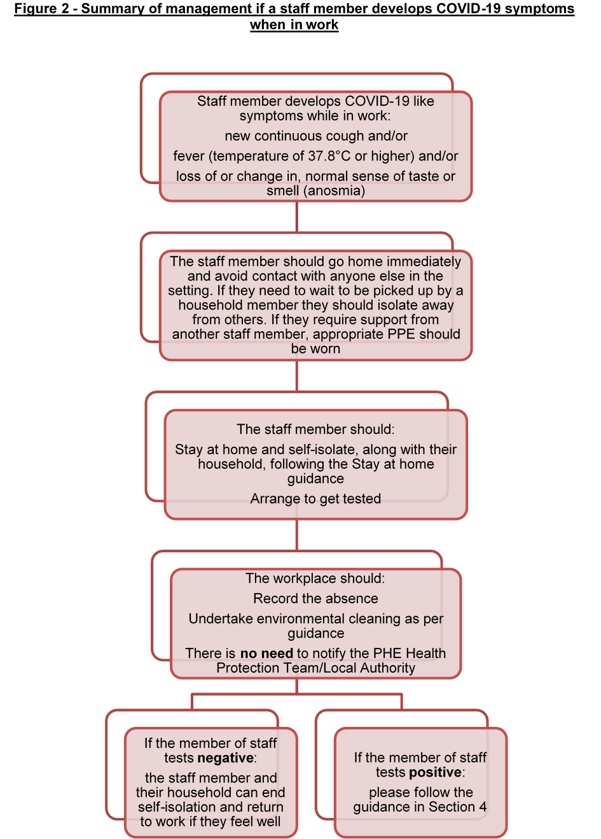

### **Section 4: Management of a single confirmed case**

**The workplace should follow the steps below:**

* The confirmed case should be advised to self-isolate until:
  + 10 days after the onset of their symptoms

or

* + 10 days after their test day if they have no symptoms
* Identify a manager or member of the leadership team to oversee the response to positives cases
* The manager or appropriate member of the leadership team should gather the following information to assist with identification of close contacts (See Appendix 1 for a Template Form and Checklist to assist with this process):
* Establish the infectious period for the confirmed case:

**The infectious period is from 48 hours before symptoms appear, and up to ten days after they start displaying symptoms. If a person tests positive but has not had symptoms the infectious period is treated as 48 hours before the date of the test, and up to ten days after the date of the test.**

* If the staff member has not been at work during the infectious period, the business does NOT need to take any further action.
* If the staff member has been at work during the infectious period, the manager should identify close contacts of the case during their infectious period. As part of the contact tracing process the manager should also determine whether staff members may have had contact with each other outside the formal workplace e.g during breaks, car sharing or socialising outside work or live in the same accommodation. This information will help inform whether transmission of COVID19 has occurred in the workplace. (See Section 2 – What is a close contact?)
* All close contacts should be told to self-isolate for 10 days following their last contact with the case, and follow [national guidance](https://www.gov.uk/government/publications/guidance-for-contacts-of-people-with-possible-or-confirmed-coronavirus-covid-19-infection-who-do-not-live-with-the-person/guidance-for-contacts-of-people-with-possible-or-confirmed-coronavirus-covid-19-infection-who-do-not-live-with-the-person). For example, if the case tests positive on Wednesday and was last in work on the previous Monday the first day of the 10 day period for their workplace contacts is the Tuesday.
* Household members of workplace contacts do not need to self-isolate unless the contact develops symptoms.
* Any setting which is identifying contacts should provide a list of contacts to 020 3743 6715 with the index case’s Account ID. The employee who has tested positive will have received this ID from NHS Test and Trace. This will log the contacts on NHS Test and Trace and allow them to receive self-isolation support payment if required
* The business should send the identified close contacts and their families a standard letter containing the advice (see Appendix 3).
* If a workplace contact remains well, they should not be tested and their household does not need to isolate. Testing is not advised if asymptomatic as the staff member must still complete their 10 day isolation even if they test negative. This is because they can develop the infection at any point up to day 10 (the incubation period for COVID19), so if a person tests negative on day 3 they may still go on to develop infection.
* If a workplace contact does develop symptoms, then they should arrange to be tested via [NHS UK](https://www.nhs.uk/conditions/coronavirus-covid-19/testing-for-coronavirus/) or by contacting NHS 119 via telephone if they do not have internet access. Their household should isolate and follow the [Stay at home guidance](https://www.gov.uk/government/publications/covid-19-stay-at-home-guidance/stay-at-home-guidance-for-households-with-possible-coronavirus-covid-19-infection). They should notify the workplace of their symptoms and of the outome of any test they have.
* If a workplace contact goes on to test positive for COVID-19 they should be managed as a new case, according to Section 4, and the guidance in Section 5 should also be followed.
* Use the working safely guidance to review any covid secure arrangements that you have in place to identify if any further measures which may be appropriate

**You do not need to contact PHE or your Local Authority about a single case, but if you have any concerns or queries please contact** [**COVID19.SPOC@knowsley.gov.uk**](mailto:COVID19.SPOC@knowsley.gov.uk)

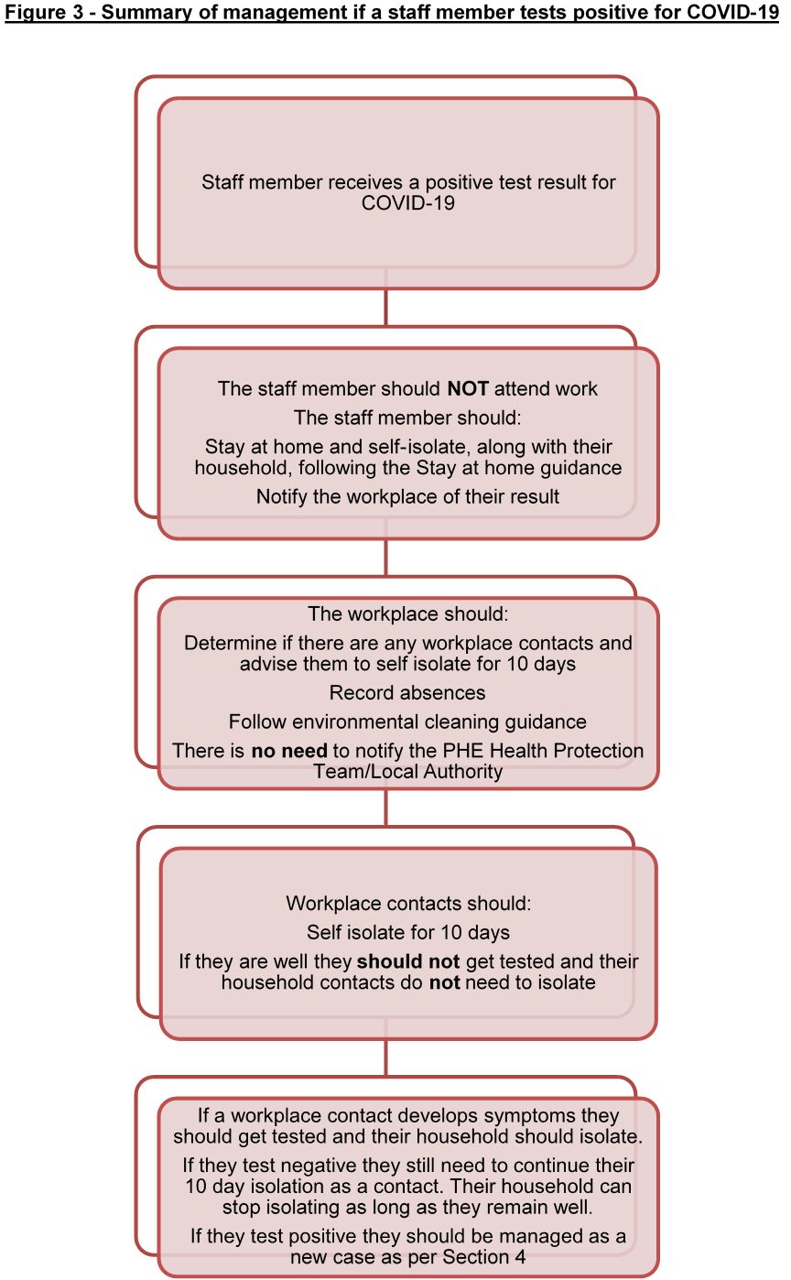

### **Section 5: Management of multiple confirmed cases and possible outbreaks**

If further staff members test positive for COVID-19 the workplace should follow the steps outlined in Section 4 to identify and exclude contacts of each subsequent confirmed case of COVID19.

It is not unusual for self-isolating staff who have been identified as close contacts of a case to report a couple of days later that they have developed symptoms or test positive for COVID19. As per Section 4, if the person was self-isolating, or did not attend work for another reason, during their infectious period there will be no further public health action required by the workplace. If the person was in the workplace during their infectious period repeat contact tracing should be undertaken as outlined in Section 4.

If cases increase you may want to establish a team to assist with coordinating the recording of cases and contacts, and the identification and implementation of further covid-secure measures, so that you reduce transmission and limit the impact on your business. This will also help you pull together information you may need should the situation develop into a workplace outbreak.

**If you are aware of multiple confirmed cases (that have tested positive) or there is a high reported absence from the workplace which is suspected to be COVID-19 related within 14 days, please use the table below to guide you as to what further action is required**

|  |  |  |
| --- | --- | --- |
| **Scenarios** | **Summary of risk** | **Action required** |
| A confirmed case has worked during their infectious period. Their contacts have been identified and are self-isolating. | The risk of transmission has passed, no further contacts in the workplace have been identified | No further action required |
| Two or more cases develops symptoms and tests positive within 14 days of each other, AND these cases have been identified as direct contacts of one another. | This is a likely outbreak | Contact tracing should be undertaken for each case. If the setting has any concern and requires support either with contact tracing or discussing implementation of COVID-safe measures, contact [COVID19.SPOC@knowsley.gov.uk](mailto:COVID19.SPOC@knowsley.gov.uk) |
| More than one case develops symptoms and tests positive within 14 days of each other. The cases have potentially spent time close to each other, e.g. they share a workspace or break room, but they have not been identified as direct contacts of each other. | This is a potential outbreak, although it may be that the cases have each caught the infection in the community | Contact tracing should be undertaken for each case. If the setting has any concern and requires support either with contact tracing or discussing implementation of COVID-safe measures, contact [COVID19.SPOC@knowsley.gov.uk](mailto:COVID19.SPOC@knowsley.gov.uk) |

Below are some other examples of situations where you might consider calling Knowsley’s Single Point of Contact (SPOC) for additional advice on [COVID19.SPOC@knowsley.gov.uk](mailto:COVID19.SPOC@knowsley.gov.uk)

(as per [Workplace Action Cards](https://coronavirusresources.phe.gov.uk/reporting-an-outbreak/resources/)):

* the number of cases exceeds 5 within 14 days.
* you’ve taken the action outlined but are still seeing more cases
* you’re thinking you might need to close because of the number of people affected
* somebody in your workplace has been admitted to hospital with confirmed COVID-19 and/or you’re getting significant interest from local media

Key information to have to hand when calling to report a potential outbreak, where possible, includes:

* Number of confirmed/possible cases
* Date of onset of symptoms or test in first case and most recent case
* Number of potential contacts
* Total number of staff
* Are any staff in hospital
* Any issues affecting safe operation of the setting
* Any communications already issued to staff

### **Section 6: Frequently Asked Questions**

**Please note**

**As COVID-19 is a rapidly evolving situation, guidance may change at short notice**

**We advise that you refer to the to** [**national guidance**](https://www.gov.uk/coronavirus-business-reopening) **in addition to this document, and updates from PHE and your local authority.**

Cases and contacts

**What is a household?**

A household is taken to mean anyone who the staff member lives with (sharing a bathroom or kitchen). It also includes anyone in their ‘support bubble’, please see [current guidance on support bubbles](https://www.gov.uk/guidance/making-a-support-bubble-with-another-household).

**Should a staff member come to the workplace if a member of their household is unwell?**

If someone in a staff member’s household is unwell with COVID-19 symptoms then the staff member should isolate for 10 days starting from the day the household member(s) became ill and follow the [Stay at home guidance](https://www.gov.uk/government/publications/covid-19-stay-at-home-guidance).

If the staff member subsequently develops symptoms they should isolate for 10 days from the date they developed symptoms and follow the [Stay at home guidance](https://www.gov.uk/government/publications/covid-19-stay-at-home-guidance).

**If a staff member who was a contact of a confirmed case tests negative, can they return to work?**

No, they should complete 10 days of isolation. This is because they can develop the infection at any point up to day 10 (the incubation period for COVID-19), so if a person tests negative on day 3 they may still go on to develop the infection.

**If a further member of their household develops symptoms while the staff member is already in self-isolation does the staff member need to restart their self-isolation period?**

If the staff member has remained well, they can return to their normal routine at the end of the 10-day period. The staff member does not need to isolate for longer than 10 days, even if other household members develop symptoms during this period.

If the staff member has developed symptoms during the 10 day isolation period, they need to be tested and, if positive, self-isolate for a further 10 days from the date of onset of their symptoms.

After 10 days if any of the household members develop symptoms then the whole household needs to start a new 10 day self-isolation period.

**If I am notified by a staff member that they are ill with symptoms of COVID-19 do I need to advise the rest of the staff to self-isolate?**

If the person who is ill has not yet been tested, or is awaiting their result, staff can attend the workplace as normal.

The staff member who is ill should stay at home, follow the [Stay at home guidance](https://www.gov.uk/government/publications/covid-19-stay-at-home-guidance) and be advised to get tested. If anyone in their household usually attends the workplace they should also be self-isolating at home for 14 days.

**If the staff member tests positive** for COVID-19,  workplace contacts should be identified and asked to isolate for 10 days. See Section 4 for more information.

**If I am notified by a staff member they have had a positive test do I need to advise other staff not to attend work or notify anybody?**

If a member of staff tests positive for COVID-19, workplace contacts should be identified and asked to isolate for 10 days. See Section 4 for more information.

**NHS Test and Trace have told my staff member that they most isolate until a certain date but this is more than 10 days since their onset of symptoms, why is this?**

This may be because the staff member did not get tested until more than five days after their symptoms started. In this scenario the isolation period is calculated as 5 days from the date of the test.

**Do I need to contact members of the public/my customers if a staff member tests positive?**

In most circumstances if the workplace is COVID secure and social distancing measures are in place than a customer should not meet the definition of a close contact. However, for some personal contact businesses e.g. hairdressers than the workplace should identify any customers who meet the definition of a close contact (See Section 2 – What is a close contact?) and notify them that they are a contact and need to self-isolate for 10 days from the date they were exposed.

The workplace should provide a list of close contacts both staff and customers to 020 3743 6715 with the index case’s Account ID. The employee who has tested positive will have received this ID from NHS Test and Trace. This will log the contacts on NHS Test and Trace and allow them to receive self-isolation support payment if required.

**A customer has informed me that they have tested positive for COVID19 what should I do?**

In most circumstances if the workplace is COVID secure and social distancing measures are in place than no action is required as staff members should not meet the definition of a close contact. If the customer has attended the workplace during their infectious period the manager should assess whether any staff member meets the definition of a close contact (See Section 2 – What is a close contact?) and advise them to self-isolate if necessary.

**Do I need to let my other customers know?**

If your customers have not been identified as contacts there is no requirement to inform them. If you are aware of multiple cases as outlined in Section 5 please contact the Knowsley Council’s SPOC who will advise you of further steps to take.

**A household member of a staff member is a contact of someone who tested positive for COVID-19, what should we do?**

If a person is known to be a contact of a confirmed case they will be advised to self-isolate and follow the [guidance for contacts.](https://www.gov.uk/government/publications/guidance-for-contacts-of-people-with-possible-or-confirmed-coronavirus-covid-19-infection-who-do-not-live-with-the-person/guidance-for-contacts-of-people-with-possible-or-confirmed-coronavirus-covid-19-infection-who-do-not-live-with-the-person)The rest of their household do not need to isolate as long as they did not also have contact with the confirmed case, and as long as nobody in the house has symptoms or tests positive.

If someone in the household develops symptoms or tests positive, the household should isolate for 10 days starting from the day the household member(s) became ill and follow the [Stay at home guidance](https://www.gov.uk/government/publications/covid-19-stay-at-home-guidance)**.**

**Who is considered a contact in a workplace?**

See Section 2 – What is a close contact?

See [guidance on contacts](https://www.gov.uk/government/publications/guidance-for-contacts-of-people-with-possible-or-confirmed-coronavirus-covid-19-infection-who-do-not-live-with-the-person/guidance-for-contacts-of-people-with-possible-or-confirmed-coronavirus-covid-19-infection-who-do-not-live-with-the-person) for more information.

**Which contacts need to self-isolate?**

Where the member of staff tests positive and they had attended the workplace during their infectious period, close contacts should be identified and advised to self-isolate in accordance with national guidance, as per Section 4.

When undertaking contact tracing, the case should be provided with the definition of close contact and asked to identify colleagues who were close contacts. Unless there is a clear reason to believe that contacts have been identified incorrectly, contacts identified by the case should be asked to self-isolate.

**A staff member reports to us that they have had contact with someone with symptoms – what should we do?**

If the person is in their household, remind the member of staff of the [government guidance](https://www.gov.uk/government/publications/covid-19-stay-at-home-guidance/stay-at-home-guidance-for-households-with-possible-coronavirus-covid-19-infection) not to leave home if anyone in the household has symptoms and for anyone with symptoms to seek a test via [NHS UK](https://www.nhs.uk/conditions/coronavirus-covid-19/testing-and-tracing/get-an-antigen-test-to-check-if-you-have-coronavirus/) or calling 119.

Workplaces should regularly remind staff members of the [Stay at home guidance](https://www.gov.uk/government/publications/covid-19-stay-at-home-guidance) and the importance of a household self-isolating if anyone in the household develops symptoms.

If the person with symptoms is not in their household they can continue to attend work unless they have been identified and contacted by NHS Test and Trace and told to self-isolate.

**If a staff member has COVID-19 symptoms, gets tested and tests negative, can they return to work even if they still have symptoms?**

If the staff member is not in their isolation period as a contact of a confirmed case, they can return to work when they are well. The staff member should not return to work until they have recovered. If they have tested negative for coronavirus they could still have influenza or another respiratory illness which they could spread to other members of staff.

If the staff member is a contact of a confirmed case they must stay at home for the 10 day isolation period, and follow [national guidance](https://www.gov.uk/government/publications/guidance-for-contacts-of-people-with-possible-or-confirmed-coronavirus-covid-19-infection-who-do-not-live-with-the-person/guidance-for-contacts-of-people-with-possible-or-confirmed-coronavirus-covid-19-infection-who-do-not-live-with-the-person), even if they test negative. This is because they can develop the infection at any point up to day 10, so if a person tests negative on day 3 they may still go on to develop the infection.

**If there are confirmed cases, does the workplace need to close?**

Where workplaces are observing [guidance on how to be COVID-secure](https://www.gov.uk/guidance/working-safely-during-coronavirus-covid-19), which will reduce risk of transmission, closure of the whole workplace may not be necessary.

Workplaces may need to close if they have widespread transmission among staff or if they have staff shortages due to illness absence or contacts being required to self-isolate. Only the contacts of a confirmed case will need to be advised not to attend setting and self-isolate at home. If there are a number of confirmed cases across the workplace at the same time then they may be advised to close by the Local Authority/PHE Health Protection Team in consultation with other partners.

Testing

**How can a staff member arrange testing?**

If a staff member has symptoms, they can arrange to be tested via [NHS UK](https://www.nhs.uk/conditions/coronavirus-covid-19/testing-for-coronavirus/) or by contacting NHS 119 via telephone if they do not have internet access.

**Will the workplace be informed of any test results?**

It is the staff member’s responsibility to tell their employer if they test positive.

**Can people be tested if they do not have symptoms?**

People should generally only be tested if they have symptoms. If your workforce cannot work from home, it is suggested that staff conduct twice weekly Lateral Flow Tests at either on-site provision, if this has been arranged, or at one of the community asymptomatic testing centres in Knowsley or across the Liverpool City Region which can be found here:

<https://sefton.maps.test-and-trace.nhs.uk/findatestcenter.html>

Depending on the prevelance levels in the community a confirmatory PCR test may be required. If you are unsure please contact: [COVID19.SPOC@Knowsley.gov.uk](mailto:COVID19.SPOC@Knowsley.gov.uk)

**What if a staff member has a positive result from a rapid test (known as a Lateral Flow Test)?**

The staff member should start self-isolation and depending on prevelance rates take a confirmatory follow-up PCR test.

If confirmatory PCR tests **are not required** workplace contact tracing should be initiated on result of the test.

If confirmatory PCR tests **are required** workplace contact tracing should be initiated on result of the PCR test. If the PCR test comes back as negative, the case can return to work, and any contacts are not required to isolate.

**If a staff member has tested positive, do they need to have a negative test result before they return to the workplace?**

No. Someone who has tested positive for COVID‐19 should not normally be retested during their illness. Where the person is well and has completed their isolation period after the first positive result, they should not be a risk to others.

However, anyone who tested positive and fully recovered, but then goes on to develop symptoms subsequently should self‐isolate and be retested for COVID‐19.

High risk groups

**Can our pregnant members of staff work? What if staff have pregnant household members?**

Most pregnant women are in the “clinically vulnerable” category and can remain at work.

All clinically vulnerable staff should take particular care to observe good hand and respiratory hygiene, maintain 2 metre distance from others and where this is not possible avoid close face to face contact and minimise time spent within 1 metres of others.

If a staff member lives with someone who is pregnant, they can work.

Please note that some pregnant women are in the “extremely clinical vulnerable” category because of additional underlying health conditions, and [different guidance](https://www.gov.uk/government/publications/guidance-on-shielding-and-protecting-extremely-vulnerable-persons-from-covid-19/guidance-on-shielding-and-protecting-extremely-vulnerable-persons-from-covid-19#cev) will apply to these individuals.

The Royal College of Obstetrics and Gynaecology (RCOG) has published [occupational health advice for employers and pregnant women](https://www.rcog.org.uk/en/guidelines-research-services/guidelines/coronavirus-pregnancy/). This document includes advice for women from 28 weeks gestation or with underlying health conditions who may be at greater risk. Pregnant women and their employers should continue to monitor for future updates to this document.

**Should staff who were previously shielding, or who are classed as clinically extremely vulnerable due to pre-existing medical conditions, attend work?**

As this is subject to frequent changes, you should consult the latest [guidance on shielding and clinically vulnerable individuals](https://www.gov.uk/government/publications/guidance-on-shielding-and-protecting-extremely-vulnerable-persons-from-covid-19/guidance-on-shielding-and-protecting-extremely-vulnerable-persons-from-covid-19). You should also review any [current local restrictions](https://www.gov.uk/government/collections/local-restrictions-areas-with-an-outbreak-of-coronavirus-covid-19) affecting your area.

**Should staff who have family in the clinically extremely vulnerable group, or who were previously shielding, be coming to work?**

Currently, staff members who live with someone who is clinically extremely vulnerable are able to return to work. However this is subject to frequent changes, so you should consult the latest [guidance on shielding and clinically vulnerable individuals](https://www.gov.uk/government/publications/guidance-on-shielding-and-protecting-extremely-vulnerable-persons-from-covid-19/guidance-on-shielding-and-protecting-extremely-vulnerable-persons-from-covid-19). You should also review any [current local restrictions](https://www.gov.uk/government/collections/local-restrictions-areas-with-an-outbreak-of-coronavirus-covid-19) affecting your area.

Staff

**We have staff who are asymptomatic but wish to be tested is this possible?**

Currently, only people who are have COVID-19 symptoms are advised to access testing. There are a number of pilots being undertaken nationally and across the North West which may offer testing to individuals who are asymptomatic.

**Can the workplace still have temporary/agency/bank staff come in if there has been multiple cases?**

Yes, as long as they observe the guidance on social distancing and other workplace measures and precautions. Local risk assessment should be undertaken and staff advised to stay home and self-isolate if they are unwell, if they are assessed as being a contact of a confirmed case in a setting or anyone in their household has symptoms.

If a staff member is well, and has not been identified as a close contact in any of their workplaces they can continue to work as normal but should do so following the relevant guidance for the setting to minimise contact and ensure social distancing is in place.

If there are concerns about a potential outbreak, as per Section 5, you should ensure the local PHE Health Protection Team and Local Authority are aware of staff in these roles as part of your discussions.

**Can staff, for example, cleaners and caterers, work for two or more workplaces?**

Yes, as long as they observe the guidance on social distancing and other workplace measures and precautions. Local risk assessment should be undertaken and staff advised to stay home and self-isolate if they are unwell, if they are assessed as being a contact of a confirmed case in a setting or anyone in their household has symptoms.

If a staff member is well, and has not been identified as a close contact in any of their workplaces they can continue to work as normal but should do so following the relevant guidance for the setting to minimise contact and ensure social distancing is in place.

**What can workplaces do to reduce the risk of COVID19 transmission?**

* Minimising contact with individuals who are unwell by ensuring that those who have coronavirus (COVID-19) symptoms, or who have someone in their household who does, do not attend work.
* Cleaning hands more often than usual - wash hands thoroughly for 20 seconds with running water and soap and dry them thoroughly or use alcohol hand rub or sanitiser ensuring that all parts of the hands are covered
* Ensuring good respiratory hygiene by promoting the ‘catch it, bin it, kill it’ approach
* Cleaning frequently touched surfaces often, using standard products https://www.gov.uk/government/publications/covid-19-decontamination-in-non-healthcare-settings/covid-19-decontamination-in-non-healthcare-settings
* Minimising contact and mixing by altering, as much as possible, the environment (such as room layout) and timetables (such as staggered break times)
* Employees should be strongly advised NOT to share cars unless they are from the same household/support bubble

**This advice should be read in conjunction with the**[Re-open your business safely guidance](https://www.gov.uk/coronavirus-business-reopening)**.**

NHS Test and Trace App

**Can I tell my staff to turn off the app while they are at work?**

No. Only in the following circumstances should the contact tracing app by turned off:

* The staff member are working behind a fixed Perspex (or equivalent) screen and are fully protected from other people (both colleagues and/or customers)
* Staff members store their phones in lockers or other communal areas

In these circumstances, staff should be reminded to turn contact tracing back on once they leave the work place.

**Which venues in England should display the official NHS QR code poster?**

Certain types of business are required to display the official NHS QR code poster such as hospitality venues, leisure services and close contact services. Further information is available [here](https://faq.covid19.nhs.uk/article/KA-01183/en-us)

Financial support

**What financial support is available for staff who are identified as contacts and need to self-isolate?**

Financial support may be available via a number of routes:

* Employer’s sick leave or special leave policy.
* Statutory Sick Pay
* If you're on a low income and you're asked to self-isolate by NHS Test and Trace, you may be able to get a £500 Test and Trace Support Payment.

Further information on how to apply can be found [here](https://www.gov.uk/government/publications/test-and-trace-support-payment-scheme-claiming-financial-support/claiming-financial-support-under-the-test-and-trace-support-payment-scheme).

The employer should ask the staff member who tested positive for their Account ID number as this will be required for any contacts identified by the workplace to receive the payment if eligible. The employer can register the workplace contacts directly with the Contact Tracing Advisory Service by calling 020 3743 6715. The workplace contacts with then be contacted by NHS Test and Trace and receive the 8-digit code to support their application for Test and Trace payments.

Cleaning

**What additional cleaning is necessary following a symptomatic or confirmed case?**

It is important to concentrate on regular cleaning of frequently touched items / surfaces. This is likely to be highly effective as high contact surfaces will present the main risk in terms of indirect transmission. So long as regular cleaning is thorough and maintained at all times there is no need for additional cleaning.

* Cleaning an area with normal household disinfectant after someone with suspected coronavirus (COVID-19) has left will reduce the risk of passing the infection on to other people.
* Wear disposable or washing-up gloves and aprons for cleaning.
* Using a disposable cloth, first clean hard surfaces with warm soapy water. Then disinfect these surfaces with the cleaning products you normally use. Pay particular attention to frequently touched areas and surfaces, such as bathrooms, grab-rails in corridors and stairwells and door handles.
* If an area has been heavily contaminated, such as with visible bodily fluids, use protection for the eyes, mouth and nose, as well as wearing gloves and an apron.
* All the disposable materials should be double-bagged, then stored securely for 72 hours then thrown away in the regular rubbish after cleaning is finished.
* Wash hands regularly with soap and water for 20 seconds, and after removing gloves, aprons and other protection used while cleaning.
* For further information, please see the [guidance](https://www.gov.uk/government/publications/covid-19-decontamination-in-non-healthcare-settings/covid-19-decontamination-in-non-healthcare-settings) for cleaning in non-health care settings

**Do toilets need to be cleaned after every use?**

No. Toilets are frequently touched surfaces, so they need to be cleaned frequently throughout the day, but not after every use (except if used by a symptomatic person whilst waiting to go home).

Increase the frequency of cleaning toilets to at least five times a day, at regular intervals. Apart from gloves and apron, there is no need for additional PPE.

Use disposable cloths or paper roll and disposable mop heads, to clean all hard surfaces, floors, chairs, door handles and sanitary fittings, following one of the options below:

* use either a combined detergent disinfectant solution at a dilution of 1000 parts per million available chlorine

or

* a household detergent followed by disinfection (1000 parts per million available chlorine). Follow manufacturer’s instructions for dilution, application and contact times for all detergents and disinfectants

or

* if an alternative disinfectant is used within the organisation, this should be checked and ensure that it is effective against enveloped viruses

Avoid creating splashes and spray when cleaning.

All the disposable materials should be double-bagged, then stored securely for 72 hours then thrown away in the regular rubbish after cleaning is finished.

### **Section 7: National Guidance Documents**

This local guidance document has been based on national PHE, NHS and government guidance. Hyperlinks to key national guidance are displayed here for reference (click on the link to be taken to the relevant guidance/information online).

Social distancing for different groups

* [Stay at home: guidance for households with possible coronavirus (COVID-19) infection](https://www.gov.uk/government/publications/covid-19-stay-at-home-guidance/stay-at-home-guidance-for-households-with-possible-coronavirus-covid-19-infection#ending-isolation)
* [Guidance on social distancing for everyone in the UK](https://www.gov.uk/government/publications/staying-alert-and-safe-social-distancing)
* [Guidance on shielding and protecting people who are clinically extremely vulnerable from COVID-19](https://www.gov.uk/government/publications/guidance-on-shielding-and-protecting-extremely-vulnerable-persons-from-covid-19/guidance-on-shielding-and-protecting-extremely-vulnerable-persons-from-covid-19)

Guidance for contacts

* [Guidance for contacts of people with possible or confirmed COVID19](https://www.gov.uk/government/publications/guidance-for-contacts-of-people-with-possible-or-confirmed-coronavirus-covid-19-infection-who-do-not-live-with-the-person/guidance-for-contacts-of-people-with-possible-or-confirmed-coronavirus-covid-19-infection-who-do-not-live-with-the-person)

Specific guidance for workplace settings

* [Working safely during coronavirus](http://www.gov.uk/guidance/working-safely-during-coronavirus-covid-19)
* [Workplace resources (Action Cards)](https://coronavirusresources.phe.gov.uk/reporting-an-outbreak/resources/)
* [Practical actions for businesses to take based on 5 main steps](https://www.gov.uk/guidance/working-safely-during-coronavirus-covid-19/5-steps-to-working-safely)
* Business support
* Coronavirus: safer transport guidance for operators
* Guidance and support for employees during coronavirus
* [Businesses to remain closed](https://www.gov.uk/government/publications/further-businesses-and-premises-to-close/further-businesses-and-premises-to-close-guidance)  (List includes exemptions)
* [Health and Safety Executive: Coronavirus: latest information and advice](https://www.hse.gov.uk/coronavirus/index.htm)
* [Health and Safety Executive: Working safely during the coronavirus outbreak](https://www.hse.gov.uk/news/working-safely-during-coronavirus-outbreak.htm)
* The Advisory, Conciliation and Arbitration Service (ACAS): Coronavirus: advice for employers and employees

Testing

* [NHS: Testing for coronavirus](https://www.nhs.uk/conditions/coronavirus-covid-19/testing-for-coronavirus/)

Infection prevention and control

In addition to specific guidance provided for workplace settings above, the following general guidance should also be reviewed

* [Cleaning in non-healthcare settings](https://www.gov.uk/government/publications/covid-19-decontamination-in-non-healthcare-settings/covid-19-decontamination-in-non-healthcare-settings)
* [5 moments for hand hygiene: with how to hand rub and how to handwash. Posters](https://www.who.int/infection-prevention/campaigns/clean-hands/5moments/en/)
* [Catch it. Bin it. Kill it.](https://campaignresources.phe.gov.uk/resources/campaigns/34/resources/2665) (Poster)

[Coronavirus Resource Centre](https://coronavirusresources.phe.gov.uk/)

* [Posters and resources](https://coronavirusresources.phe.gov.uk/)

### Appendix 1 – Case Management Checklist

Please find a template form and checklist to assist with the management of individual cases and their contacts.



### Appendix 2 – Absence Recording Templates

Please find below example templates which you may wish to use for recording details of staff absence and illness. Please note these documents and their contents should be managed and stored in line with your local data protection policies.





### Appendix 3 – Template Workplace Letters

Please find below template letters which you may wish to distribute to staff in the event of one or confirmed cases of COVID-19 in the workplace. The letters should be updated with your workplace branding/stationery and the relevant date. The highlighted sections will need amending prior to distribution.

Letter for a staff member who is a confirmed case of COVID-19



Letter for a staff member who has been identified as a workplace contact of a confirmed case of COVID-19



Letter for staff members who are not confirmed cases or workplace contacts, notifying them of the case(s) of COVID-19 in the setting

